Team Members: __________________
Total Points (100 pts): __________________
Due: After Thanksgiving

Semester Project: Automatic Grading System

CSCI 4520 Rapid Java Application Development
Armstrong Atlantic State University

Team: Form a team with 3 members. You will learn how to work in a team. You will learn from your teammates and learn how to teach your teammates as well.

Problem Description:

Develop a Web application with the following requirements:

- Creating accounts:
  - Enable the instructor to create instructor accounts. The signup code for instructor is instructor.
  - Enable the students to create accounts that are linked to the instructor’s course ID. The signup code for student is student.

- Assign exercises:
  - Load the exercises into the database. Suppose a set of programming exercises is given. The description of each exercise is stored in a file named Exercisei_j. These files are stored in c:\ags5520\exercisedescription.
  - Enable the instructor to assign exercises, and set a due date/time and a score for the assigned exercise.

- Complete exercises:
  - Enable the student to select a programming exercise, compile/run/submit its solution, and receive automatic feedback and a score (whether the program compiles and runs correctly).
  - How do you grade the program?
The test data for each exercise is given in c:\ags5520\gradeexercise. If the exercise does not require input, the test data is stored in Exercisei_j.output. If the exercise requires input, the test data is stored in Exercisei_ja.input, Exercisei_jb.input, … for input and Exercisei_ja.output, Exercisei_jb.output, … for output.

- You can download the database definition script from www.cs.armstrong.edu/liang/script.txt. Run the script from username agsuser and password agsuser from localhost.

5. Download the exercise definition file from www.cs.armstrong.edu/liang/ags5520.zip. Unzip it to c:\

6. Write a program to load the data from ags5520 into the DefaultExercise table.

*******

When your Web project is launched, it reads the exercise descriptions from the files and stores them in an array. The user can select an exercise from a combo box. Once an exercise is selected, its description is displayed. The user can then enter the source code for the exercise in a text area and click the Run button, which first compiles the program and then runs it using the test input (if applicable). The result of the run is graded using the test output.

When you click the Run button, compile the file. Display the compile errors if the program does not compile. Otherwise, run the program with test input and display test result.

The exercise is graded by matching the tokens in the test output file with the exercise output. The tokens are delimited by the pound sign (#). All tokens must appear in the exercise output in order for the program to be graded correctly.

Issues:

Security:

How do you compile a program from AGS?

How do you run a program from AGS?

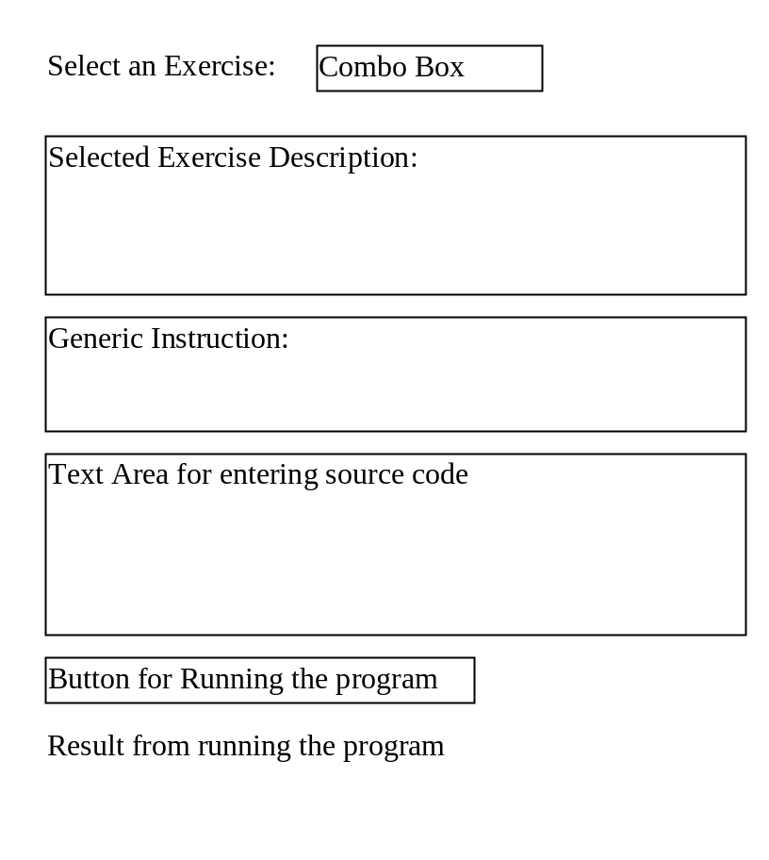

Requirements:
(1) Use JSP, NetBeans Visual Web JSF, or IceFaces.
(2) Develop the program on Windows or Unix.

What to submit?

- Name your project 5520AGSLastNames. Send me a .zip file of your project.

2. Fill in self-evaluation:

- Can your program display the GUI? _______________
- Can your program let the user choose an exercise? _______________
- Can your program display compile errors? _______________
- Can your program run programs and display run results? _______________
- Can your program enforce proper security? _______________
- Can your program handle concurrent users with interferences? _______________
- Can your program terminate infinite loops? _______________

